HIGHLAND HEIGHTS HURRICANES SWIM TEAM SPIRIT WEAR ORDER FORM
Please check the item(s) you would like to order and circle the size.
Make checks payable to HURRICANES SWIM TEAM BOOSTER CLUB. Paypal- HurricanesHH@gmail.com

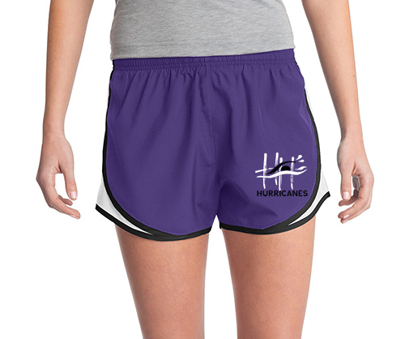 | _____ LADIES CADENCE SHORT : Screen-printed with HURRICANES logo on lower left leg: $18.00 ea….ADD $3.00 for 2XL  - 2.4-ounce, 100% polyester shell  - 3.8-ounce, 100% moisture-wicking polyester tricot side panels  - 2.8-ounce, 100% moisture-wicking polyester crepe jersey built-in brief  - Tag-free label  - Elastic waistband with drawcord  - 3.25-inch inseam  - Interior pocket for keys and small items  Color: PURPLE/WHITE/BLACK  Size: XS, S, M, L, XL, 2XL (circle one)
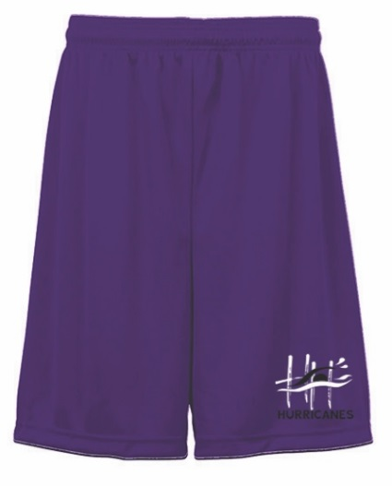 | _____ YOUTH & MEN’S DRY-FIT SHORT : Screen-printed with HURRICANES logo on lower left leg: $15.00 ea….ADD $3.00 for 2XL  - 100% polyester moisture management/antimicrobial performance fabric  - Double-needle hem  - 6" Inseam YOUTH ….9” Inseam ADULT  - 1.5" Covered elastic waistband and drawcord  Color: PURPLE  Size: YS, YM, YL, YXL, S, M, L, XL, 2XL (circle one)
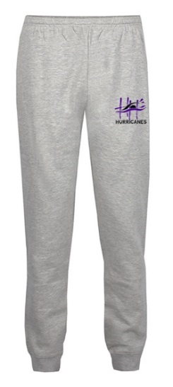 | _____ JOGGER PANT : BADGER FLEECE Jogger Pant Screen-printed with HURRICANES logo on upper left leg: $30.00 ea…..  ADD $3.00 for 2XL  Color: OXFORD  STYLE: YOUTH or MEN’S or LADIES (circle one)  Size: XS, S, M, L, XL, 2XL (circle one)
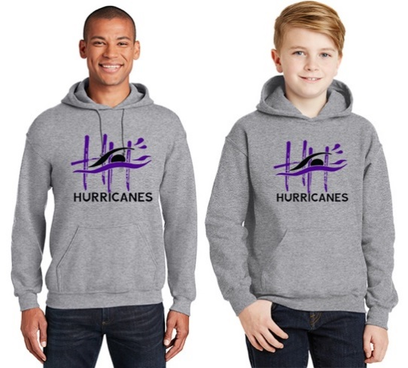 | _____ HOODIE : Screen-printed with HURRICANES logo on full front: $22.00 ea…..ADD $3.00 FOR 2XL  Color: SPORT GREY  Size: YS, YM, YL, YXL, S, M, L, XL, 2XL (circle one)
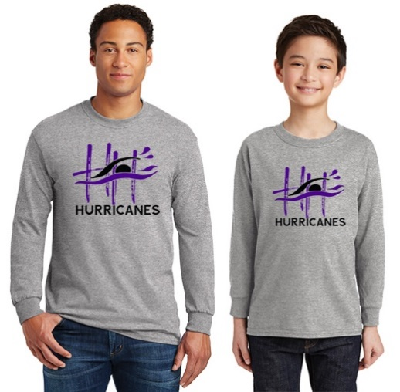 | _____ LONG SLEEVE T-SHIRT : Screen-printed with HURRICANES logo on full front: $12.00 ea…..ADD $3.00 FOR 2XL  Color: SPORT GREY  Size: YS, YM, YL, YXL, S, M, L, XL, 2XL (circle one)
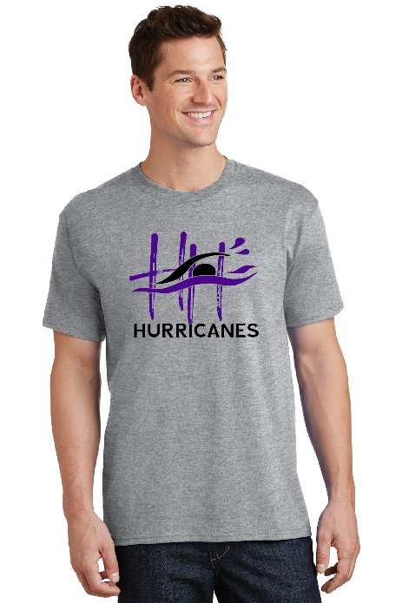 | SHORT SLEEVE T-SHIRT : Screen-printed with HURRICANES logo on full front: $10.00 ea…..ADD $3.00 FOR 2XL  Color: SPORT GREY  Size: YS, YM, YL, YXL, S, M, L, XL, 2XL (circle one)
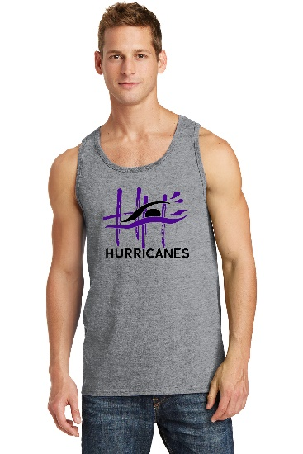  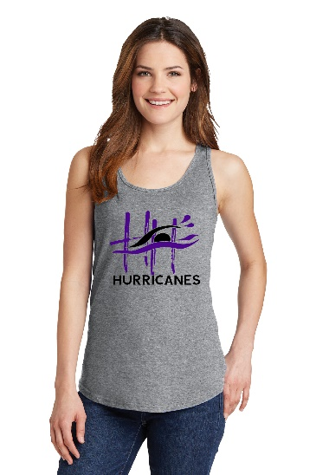 | TANK TOP : Screen-printed with HURRICANES logo on full front: $11.00 ea…..ADD $3.00 FOR 2XL  Color: SPORT GREY  Women’s or Men’s (circle one)  Size: S, M, L, XL, 2XL (circle one)
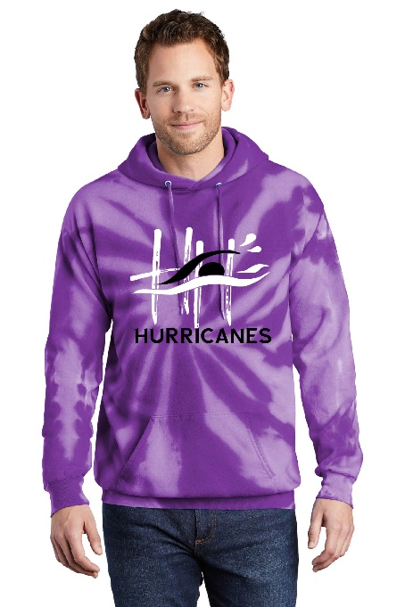 | _____ Tie Dye Hoodie  $30.00 ea….ADD $3.00 for 2XL  - Screen printed with Hurricanes logo on full front  Color: PURPLE  Size: YS, YM, YL, YXL, S, M, L, XL, 2XL (circle one)
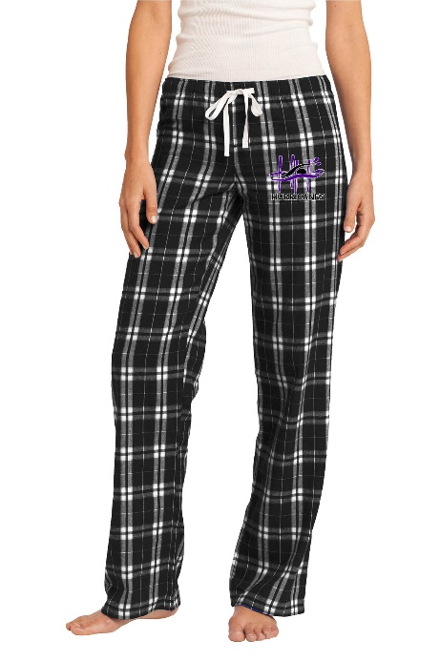 | _____ Women’s Flannel Plaid Pant  $22.00 ea….ADD $3.00 for 2XL  - Embroidered with Hurricanes logo on upper left leg  Color: Black & White Plaid  Size: S, M, L, XL, 2XL
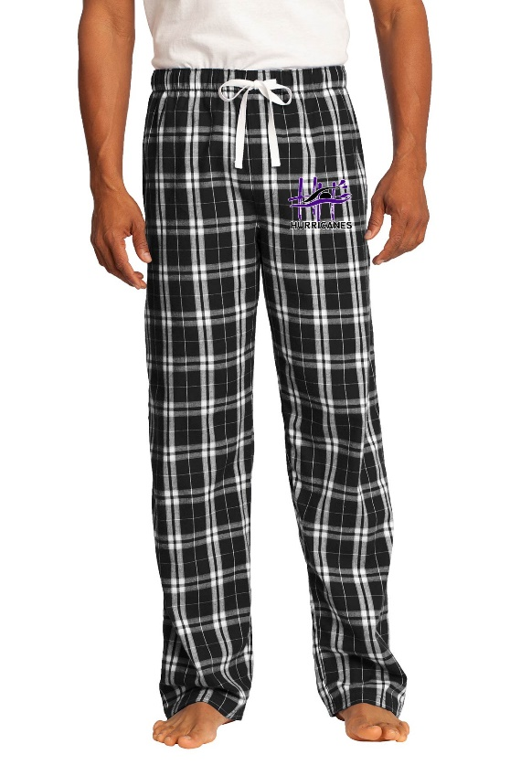 | _____ Men’s Flannel Plaid Pant  $22.00 ea….ADD $3.00 for 2XL  - Embroidererd with Hurricanes logo on upper left leg  Color: Black & White Plaid  Size: S, M, L, XL, 2XL

ANY QUESTIONS CONTACT NICOLE 216-337-5566 or SAM 440-476-8887
ALL ORDERS DUE BY June 2nd.

NAME ______________________ TOTAL $_____________

**You can give this form and check to any coach or mail it to Karrie Faiman at 6292 Coldstream Road, Highland Heights, 44143

